Debounce time from a microswitch gamecontroller.= 1 uS

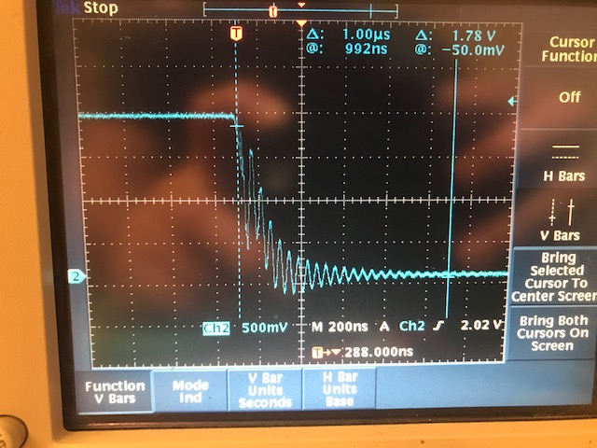

Debounce time from a microswitch with a transistor BC547 .= 1 uS

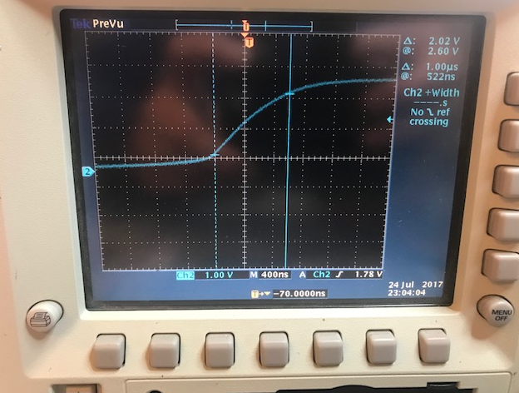

The Looptime for the Arduino program = 1,2 mS

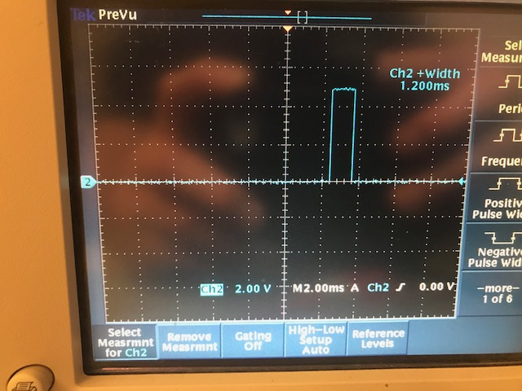

The Time to fill the array with 8 values and to find the highest value cost a little time to work fine.

I decreased the array to only 5 values now and that also work good.